Assignment-2

Kali linux and metasploitable2 installation in Vmware

Name: Gopalakrishnan K
Date : 01-03-2024
E-mail: Gopalakrishnancnc45@gmail.com

System Requirements
The requirements for VMware Player and VMware Workstation Pro are very similar, as detailed below.
- CPU: You'll need a 64-bit processor with a core speed of at least 1.3 GHz.
- RAM: A minimum of 2 GB of memory is necessary, but we recommend 4 GB or more.
- Disk Space: Workstation Player only requires 150 MB of free disk space for installing the software. If you install Workstation Pro, you'll require approximately 1.2 GB of free disk space for the application installation.
Here are the minimum system requirements for installing Kali Linux on VMware:
- At least 2 GB of RAM, although we recommend 4 GB or higher.
- At least 20 GB of free hard disk space.

Download vmware workstation

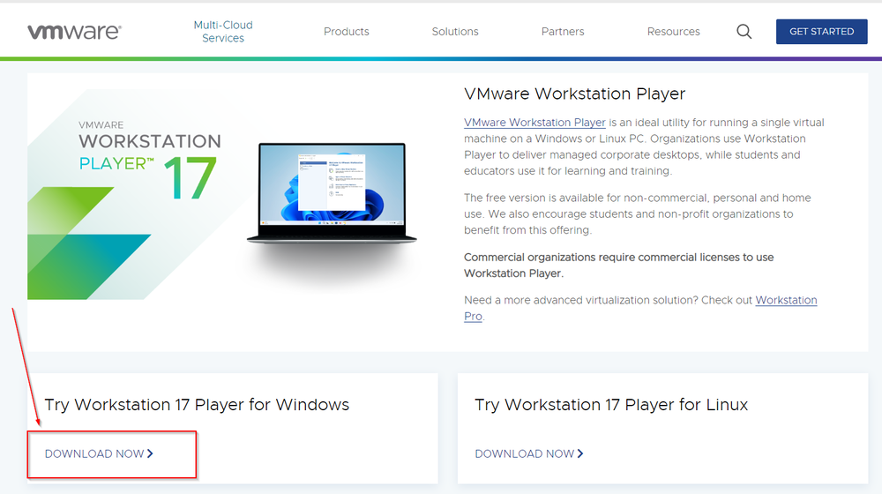
Download the installer, and when completed, double-click on the VMware installer file from the folder you saved it to and start the installation process. Click Next.
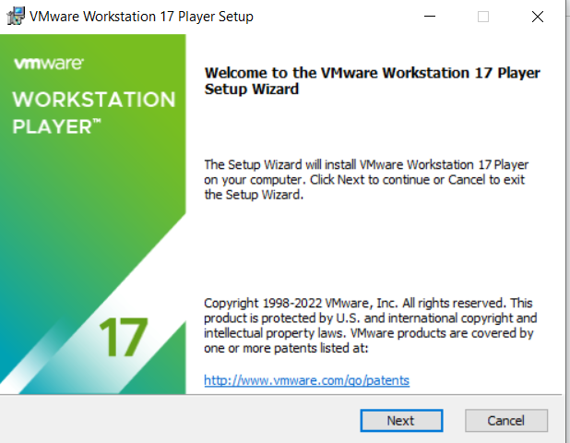
Accept the license agreement and click Next. Click Next three more times, and finally, click Install. Once VMware is installed, click Finish, and you can proceed to install Kali on VMware.
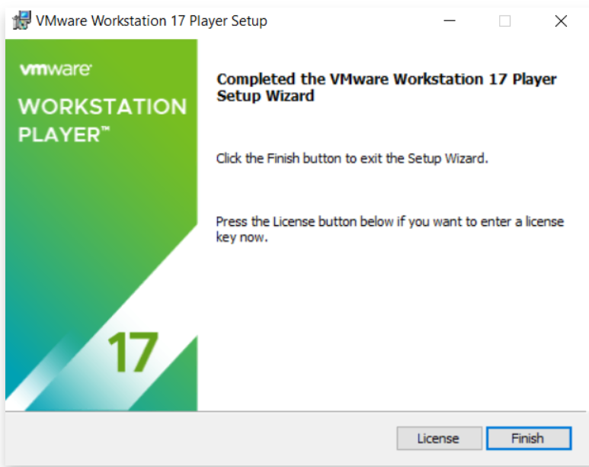

Downloading Kali
There are two ways we can download and install Kali on VMware, using the .iso or the VMware image file.

Using a Virtual Machine Image
To download the Kali VMware image, follow these steps:
1. Go to the official Kali Linux website (Download Kali).
2. Scroll down to the "Virtual Machines" section.
3. Choose the VMware platform and click on the download link.
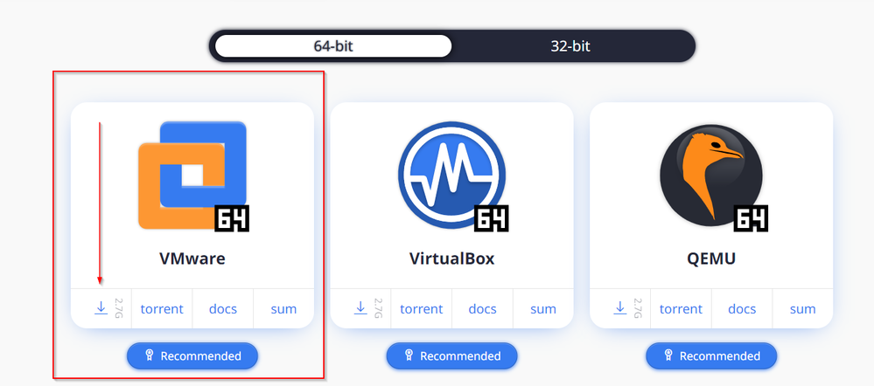

How to Install Kali Linux on VMware
Once the download is complete, you will notice it saved as a .zip file. Double-click on the downloaded file to open it with your default zip program. If you need a zip program, we recommend 7Zip.
Set where you would like the file to be extracted and click OK.
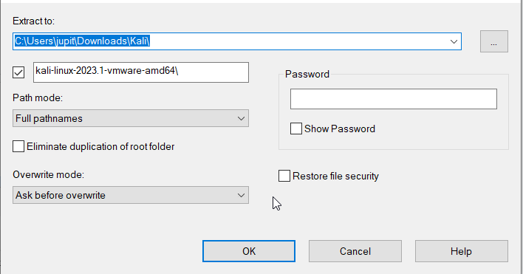
We will show you how to Install the image on both the Player and Pro versions, which are very similar.

VMware Workstation Pro
Here is how to install Kali Linux on VMware Workstation Pro, which is very similar to how we installed it on VMware Workstation Player. Open VMware Pro and click on “Open a Virtual Machine.”
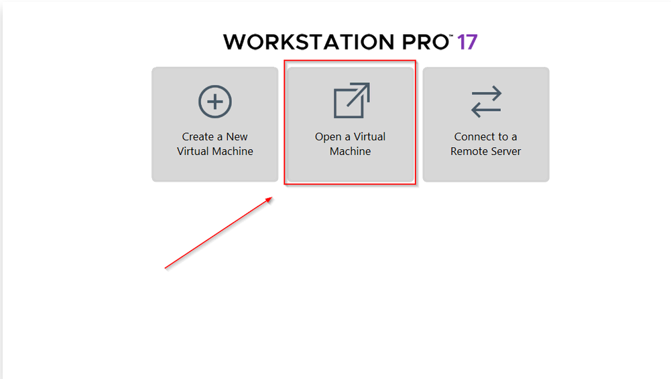
Locate the extracted Kali VMware virtual configuration file and click Open.
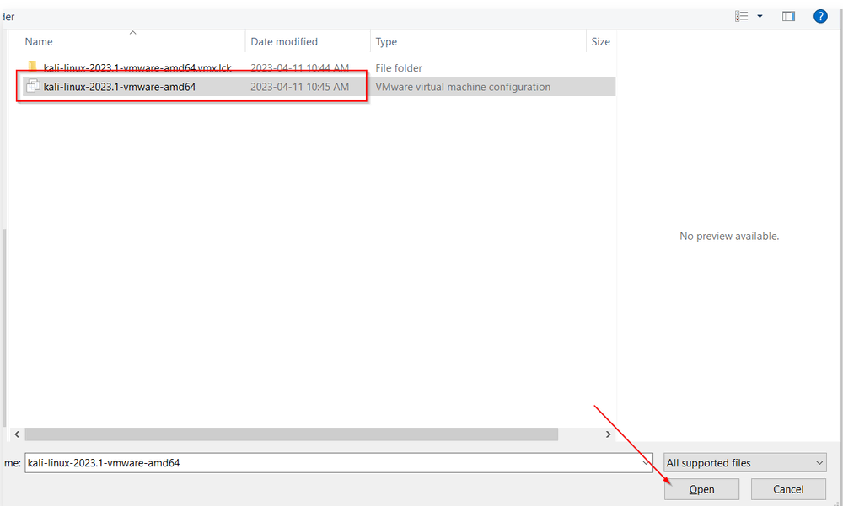
Click on “Power on this virtual machine” and Kali will load.
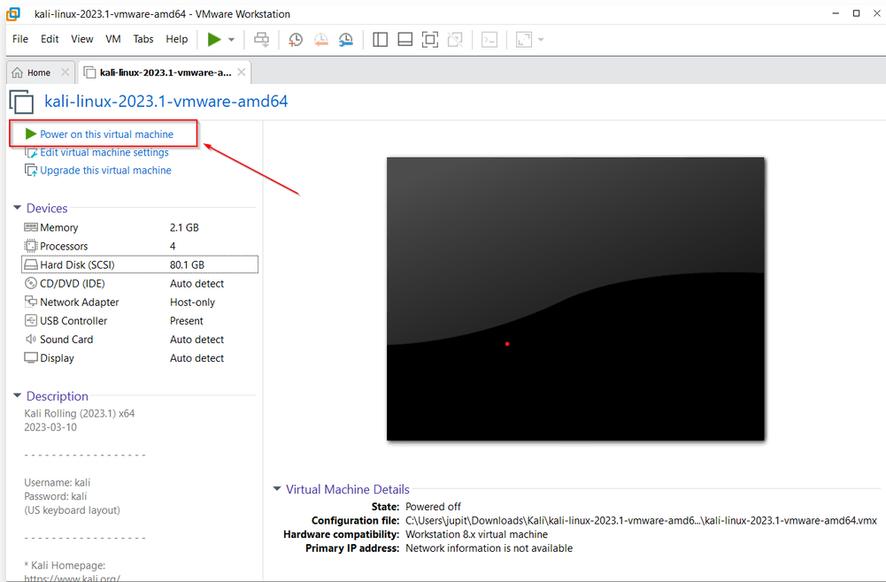

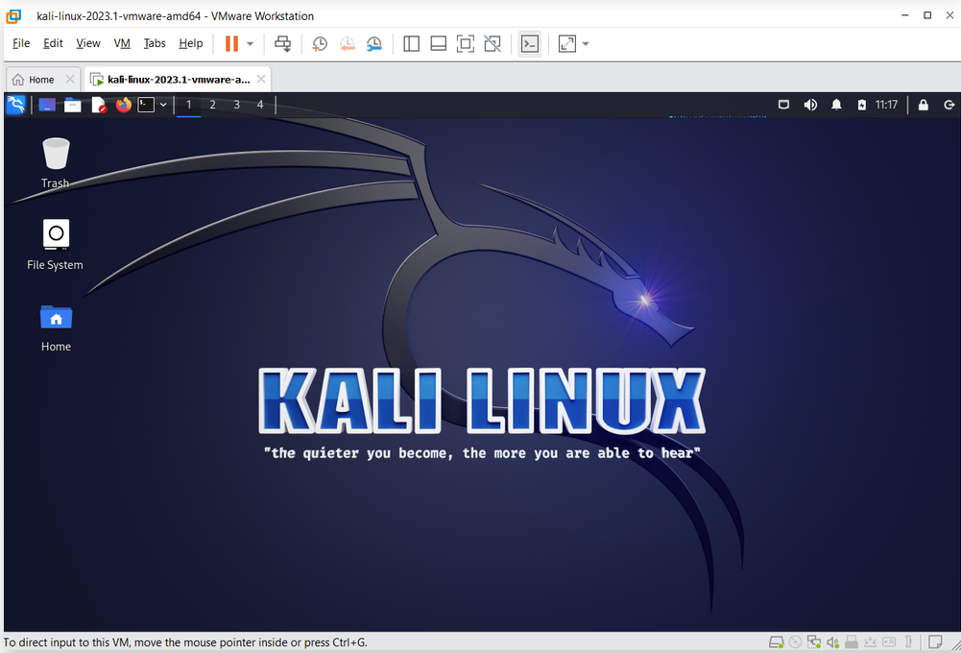

Metasploitable2 installation

Visit the Sourceforge website and search Metasploitable2. Alternatively, here is the direct link: https://sourceforge.net/projects/metasploitable2/.
Click on the Download button
extract zipfile and move folder to vmware work folder
double click on vmx file to open machine.
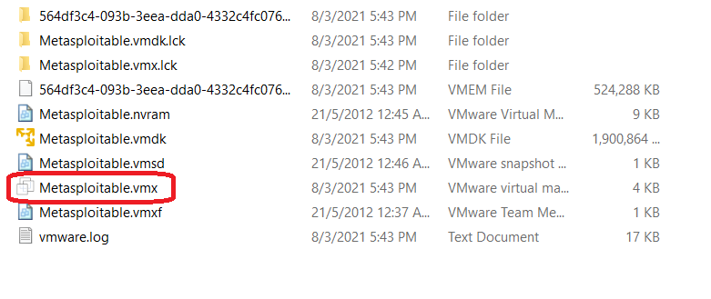Runing os in vmware and userid/password is msfadmin/msfadmin
Then find ip command ifconfig
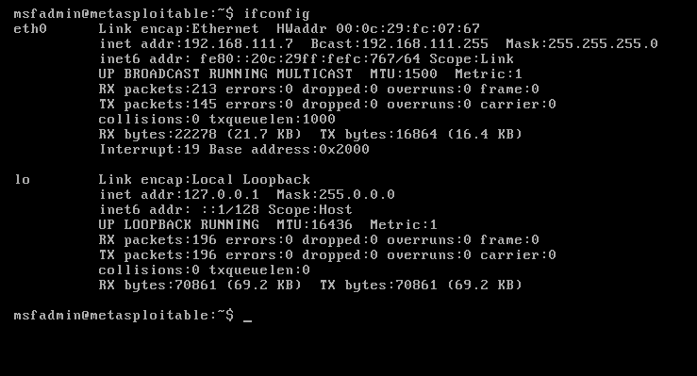

After kali linux search using browser using ip address
